CS 255 System Design Document Template

This template lays out all the different sections that you need to complete for Project Two. Each section has guidance to prompt your thinking. You will need to continually reference the interview transcript as you work to make sure that you are addressing your client’s needs. There is no required length for the final document. Instead the goal is to complete each section based on what your client’s needs are. Remove this note when you are finished, and replace all bracketed text with the relevant information.

UML Diagrams

UML Use Case Diagram
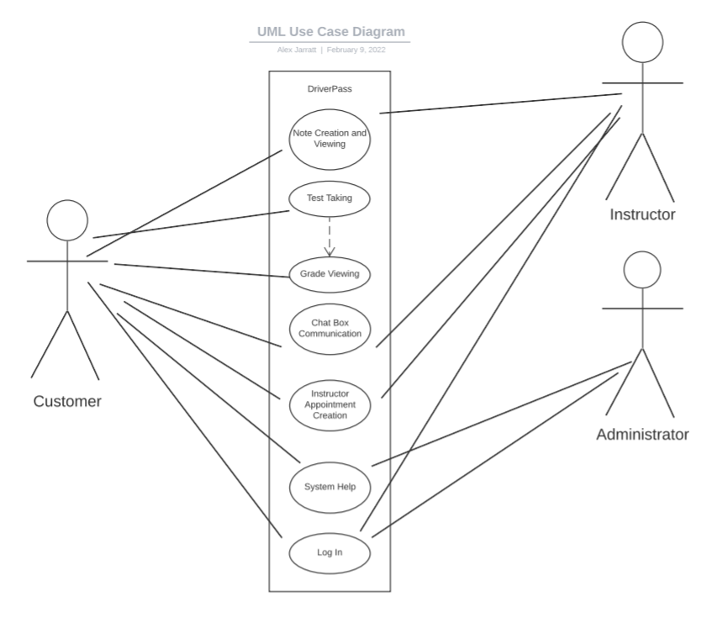

UML Activity Diagrams
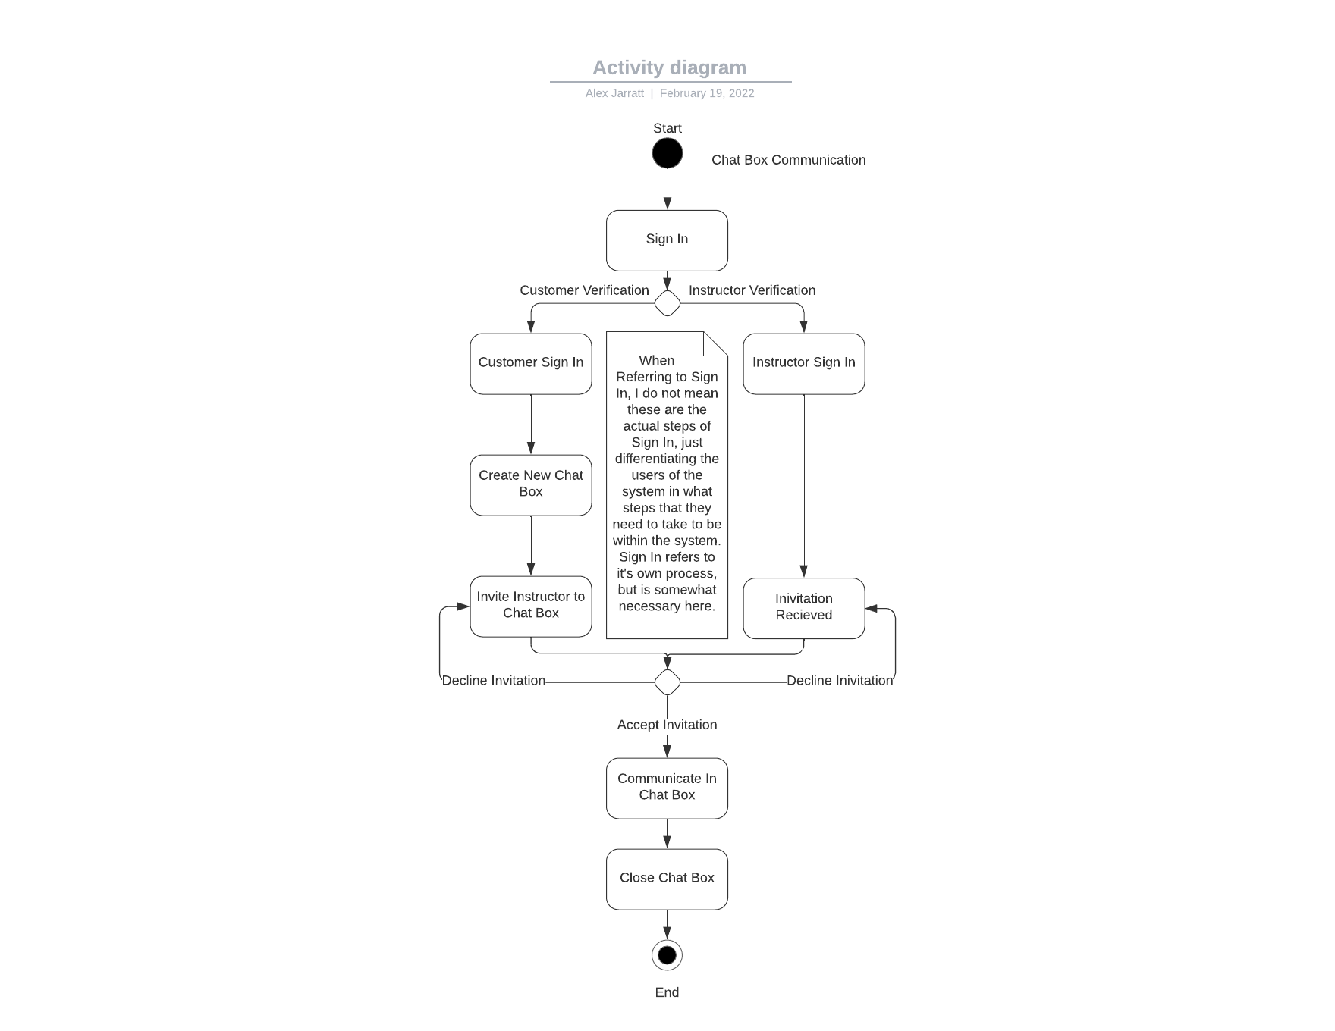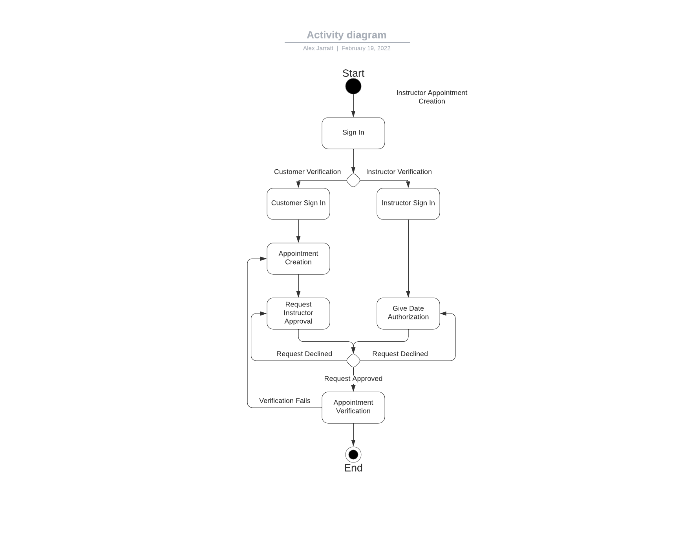

UML Sequence Diagram
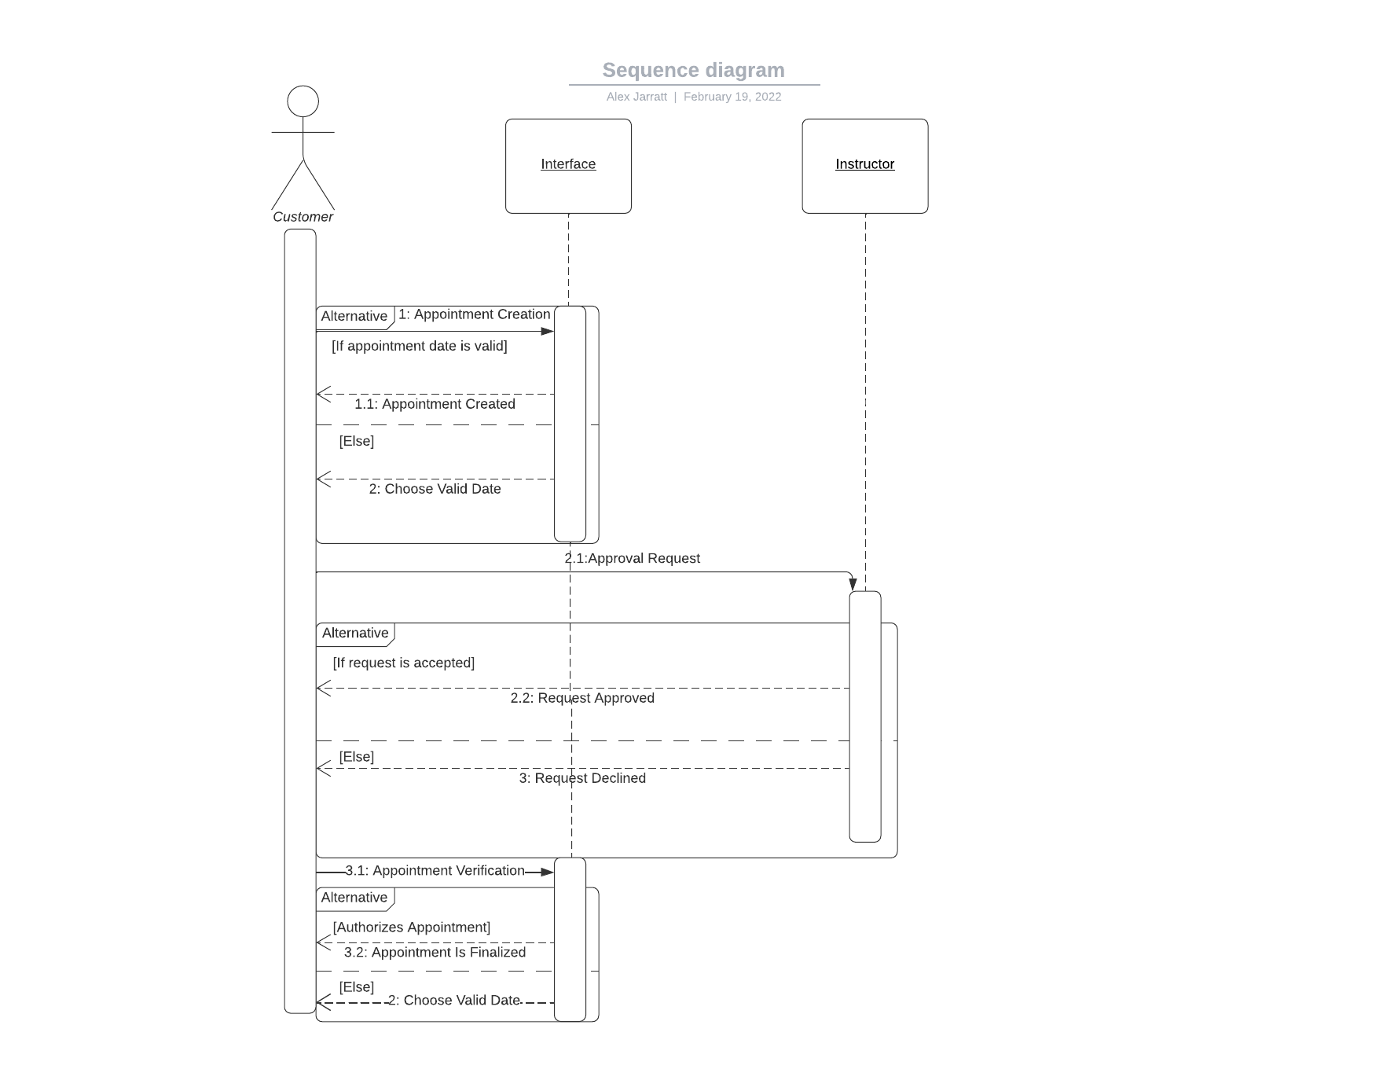

UML Class Diagram
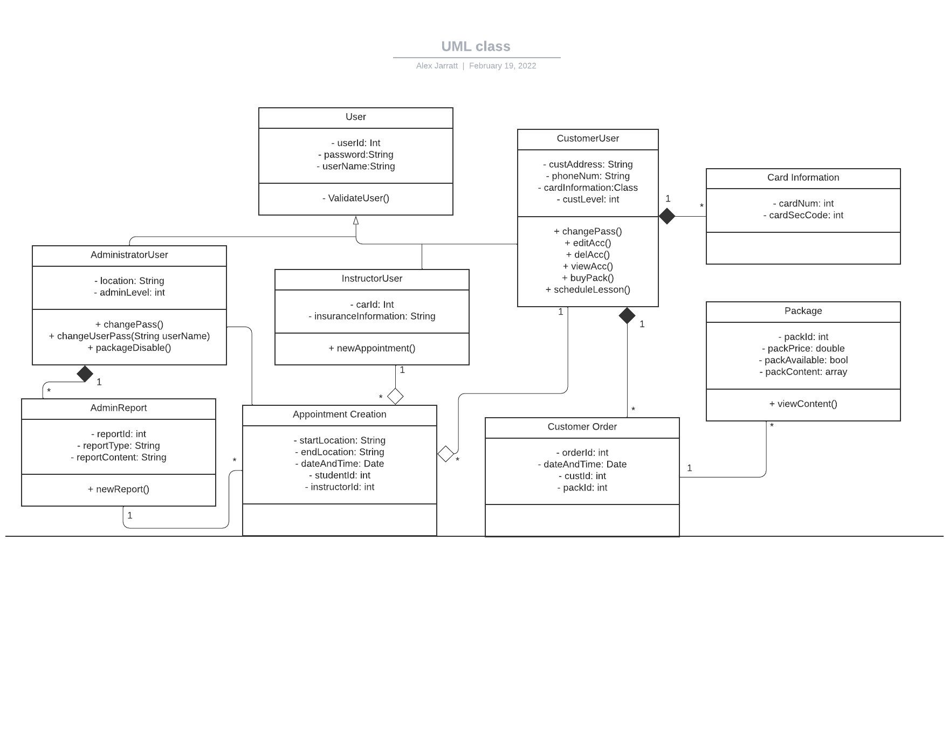

Technical Requirements

Hardware Requirements:
- Customer
- A computer (Laptops, Desktops, Mobile Devices, etc.)
- A working power supply
- A connection to the internet (wireless or wired)
- An internet provider
- Interactive devices (mouse, keyboard, etc.)(Only for Desktop)
- System Provider
- A server
- A working power supply
- An internet provider
- A set of networking cables for the server and required equipment
- Interactive devices (mouse, keyboard, etc.)

Software Requirements:
- Customer
- One Operating System (Windows, Apple, Linux, etc.)
- Web search application (Chrome, Edge, Bing, etc.)
- Some form of personal security software
- System Provider
- Windows Server OS
- Some form of Server-based Security Software
- DriverPass software
- Some form of VM traffic control software

Tool Requirements:
- Customer
- None.
- System Provider
- Some form of IDE or programming software (Eclipse, Visual Studio, Notepad++, etc.)
  - This must be on a computer with an OS
- Internet Connection to upload to server
- Administrator Networking tools for security/various administrator-based tasks

Infrastructure Requirements:
- Customer
- None.
- System Provider
- Location for server
- Power for the building
- Internet for the building
  - More Robust internet speeds necessary
- Parking
- Cars for instructors
- Insurance for all necessary parts
- Credit card processing company partnership

